ASSIGNMENT NO. 2
Clustering Techniques using Unsupervised Learning

Aim
To group similar data points with K-Means and hierarchical clustering, without giving the model any labels.

Objectives
- Understand what unsupervised learning is.
- Apply K-Means clustering to a dataset.
- Use the elbow method to pick the number of clusters.
- Compare K-Means with agglomerative (hierarchical) clustering using the silhouette score.

Software and tools
Python 3, written and run in Jupyter Notebook (VS Code works too) on Windows. Libraries used: numpy, matplotlib and scikit-learn.

Theory

1. Supervised vs unsupervised learning
In supervised learning every row comes with the right answer, called a label, and the model learns from these solved examples. Unsupervised learning has no answers at all. The model only gets the data and has to find the structure by itself.
Think of a box of mixed buttons. Nobody tells you what the groups should be, but you'd still end up sorting them by colour or size. An unsupervised model does the same thing with data.

2. What clustering is
Clustering splits data into groups so that items in the same group are alike and items in different groups aren't. Shops use it to group customers with similar buying habits. News apps use it to put stories about the same event together. Banks use it to catch transactions that don't fit any normal group, and image tools use it to cut down the number of colours in a picture.

3. The K-Means algorithm
K-Means is the most widely used clustering method because it is simple and quick. K is the number of clusters we ask for. It runs in a loop:
- Choose the number of clusters, k.
- Pick k random points as the starting centres (centroids).
- Assign every point to its nearest centroid.
- Move each centroid to the average position of the points assigned to it.
- Repeat steps 3 and 4 until the centroids stop moving.
"Nearest" here means straight-line (Euclidean) distance:
d = √[ (x₁ − x₂)² + (y₁ − y₂)² ]

4. Choosing k with the elbow method
K-Means can't decide k on its own, so we run it for k = 1, 2, 3 and so on and record the WCSS (within-cluster sum of squares) each time. WCSS adds up the squared distance from every point to its own centroid. It always drops as k goes up, but after a point the drop gets small. On a graph that point looks like a bent elbow, and it's usually a good choice for k.

5. Silhouette score
The silhouette score measures how well separated the clusters are. It runs from −1 to +1. Close to +1 means points sit near their own cluster and far from the others. Near 0 means the clusters overlap.

6. Hierarchical (agglomerative) clustering
This method starts with every point as its own cluster and keeps merging the two closest clusters until only the number we asked for is left. The merging history can be drawn as a tree called a dendrogram. There's no random start, so it gives the same answer every run, but it gets slow on large datasets.

7. Why scaling matters
Both methods work with distances. If one column runs into the thousands and another stays between 0 and 1, the large one decides everything. StandardScaler fixes this by giving every column a mean of 0 and a standard deviation of 1.

Dataset used
The Iris dataset from scikit-learn: 150 flowers, each with four measurements (sepal length, sepal width, petal length and petal width). The dataset also records the species, but we left the labels out completely. We do know there are three species, which makes Iris a good test of whether clustering can find natural groups by itself.

Procedure
- Import the libraries.
- Load only the four measurement columns of Iris.
- Scale the data with StandardScaler.
- Run K-Means for k = 1 to 10, store the WCSS and draw the elbow graph.
- Pick k = 3 from the graph and train the final K-Means model.
- Print the size of each cluster and the silhouette score.
- Run agglomerative clustering with 3 clusters and compare its silhouette score.
- Plot the clusters and their centroids.

Program
# Assignment 2 - Clustering using unsupervised learning
import numpy as np
import matplotlib.pyplot as plt
from sklearn.datasets import load_iris
from sklearn.preprocessing import StandardScaler
from sklearn.cluster import KMeans, AgglomerativeClustering
from sklearn.metrics import silhouette_score

# we only take the measurements, the flower names are NOT used
X = load_iris().data
X = StandardScaler().fit_transform(X)

# elbow method: try k from 1 to 10
wcss = []
for k in range(1, 11):
km = KMeans(n_clusters=k, n_init=10, random_state=42)
km.fit(X)
wcss.append(km.inertia_)
print("WCSS for k = 1 to 10:")
print(np.round(wcss, 2))

plt.figure(figsize=(6, 4))
plt.plot(range(1, 11), wcss, marker='o')
plt.xlabel('Number of clusters (k)')
plt.ylabel('WCSS')
plt.title('Elbow Method')
plt.tight_layout()
plt.savefig('a2_elbow.png')
plt.show()

# final K-Means with k = 3
km = KMeans(n_clusters=3, n_init=10, random_state=42)
labels = km.fit_predict(X)
print("\nPoints in each K-Means cluster:", np.bincount(labels))
print("Silhouette score (K-Means):", round(silhouette_score(X, labels), 3))

# hierarchical clustering for comparison
agg = AgglomerativeClustering(n_clusters=3)
labels2 = agg.fit_predict(X)
print("Points in each Agglomerative cluster:", np.bincount(labels2))
print("Silhouette score (Agglomerative):", round(silhouette_score(X, labels2), 3))

# plot the clusters using petal length and petal width
plt.figure(figsize=(6, 4))
plt.scatter(X[:, 2], X[:, 3], c=labels, cmap='viridis', s=20)
plt.scatter(km.cluster_centers_[:, 2], km.cluster_centers_[:, 3],
c='red', marker='X', s=200, label='Centroids')
plt.xlabel('Petal length (scaled)')
plt.ylabel('Petal width (scaled)')
plt.title('K-Means Clusters (k = 3)')
plt.legend()
plt.tight_layout()
plt.savefig('a2_clusters.png')
plt.show()

Output
WCSS for k = 1 to 10:
[600. 222.36 139.82 114.09 90.93 81.54 72.63 62.54 55.12 47.39]

Points in each K-Means cluster: [53 50 47]
Silhouette score (K-Means): 0.46
Points in each Agglomerative cluster: [71 49 30]
Silhouette score (Agglomerative): 0.447

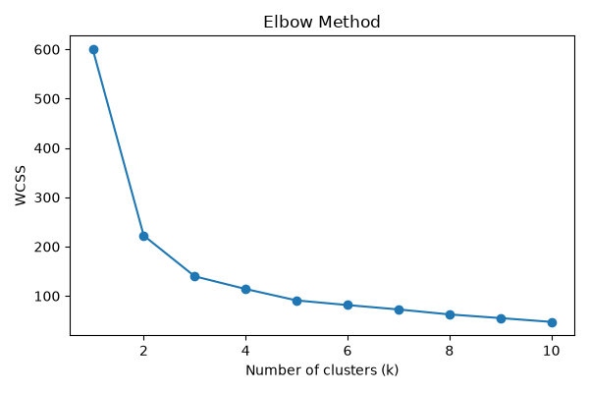
Figure 2.1: Elbow graph (WCSS against number of clusters)
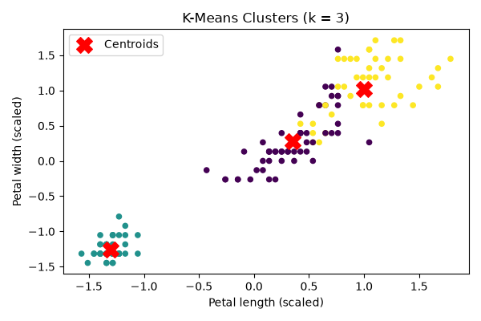
Figure 2.2: Clusters found by K-Means

Observations
- WCSS drops sharply from 600 at k = 1 to 139.82 at k = 3, then flattens out. The elbow is at k = 3.
- K-Means made clusters of 53, 50 and 47 points. That's very close to the real 50 per species, and it never saw the species names.
- K-Means scored 0.46 on silhouette, a little better than agglomerative clustering's 0.447.
- Agglomerative clustering split the points less evenly: 71, 49 and 30.
- In the cluster plot, one group in the bottom left sits completely apart. The other two touch slightly, so neither method can separate them perfectly.

Conclusion
The elbow method pointed to three clusters for the Iris data, and K-Means found groups that closely match the three real species without seeing a single label. It also separated the data slightly better than hierarchical clustering. When there are no labels to learn from, clustering is a quick way to see what groups the data already has.

